

**TELEX**

TXo & TXi

QUICK START GUIDE

and

HANDY COMMAND REFERENCE

Revision .013b • 20170425

©2017 bpcmusic

**Welcome**

Congrats on purchasing or building your TELEX module(s). This endeavor has been a massive learning experience and a serious labor of love to put together for us. Your support has been sincerely appreciated all along the way of this journey!

This quick guide is an attempt to consolidate some important details for you and get you up and running in no time with your TELEX. While you may not be a “read the manual” type of person, you will very likely save yourself a lot of time and frustration by giving this a quick glance. But, who are we kidding, if you aren’t a read the manual type of person then you aren’t even reading this and we’re just wasting everyone’s time. We all blame you for this.

If you run into any problems along the way, feel free to reach out for assistance. The best place to do this is on the monome forum “lines” at:

http://llllllll.co/t/a-teletype-expander

Getting Started: Firmware

Required Teletype Firmware

Your Telex module(s) require firmware later than version 1.4 to be installed on your Teletype. Head on over to the monome repository and update that firmware if you want the Teletype to be able to speak with your TELEX. Instructions for the Teletype update process are also on the monome site.

https://github.com/monome/teletype/releases

It is highly recommended to install the 2.0 firmware for the Teletype when it becomes final as it will provide stability improvements – especially when using external modules.

TELEX Firmware Upgrades

Your TELEX shipped with the latest firmware available at the time of its construction. If some time has passed, there is a good chance that a new version may be available. You can always check at the GitHub TELEX microsite:

https://github.com/bpcmusic/telex/releases

To upgrade your firmware, you will need to connect the Teensy processor on the back of your TELEX to your computer. It is critical to turn the power off on your TELEX or (better) simply remove the Teensy from the back of the module during this operation. Follow the procedure for loading firmware onto the Teensy that is appropriate for your operating system using the Teensy Loader. Links and details are on the release page above.

DO NOT connect your module’s Teensy processor to USB while it is connected to Eurorack power. This will cause bad things to happen. Chernobyl-style bad things. Resist the temptation – it will only lead to wanton destruction.

If you wish to roll up your sleeves and debug the module via USB, you will need to separate VIN from VUSB on the underside of the Teensy. This is a simple procedure that should be done carefully to ensure that you don’t damage your Teensy, module, computer, or fabric of the universe.

Getting Started: Connections

Connecting Your TELEX to Eurorack Power

The TELEX modules follow the “red stripe down” paradigm of power connections. This means that the -12 side of your Eurorack cable should be at the bottom of the module. This is marked on the silkscreen as “< -12” alongside the vertical Eurorack power connector.

While the TELEX was designed with reverse power protection, this hasn’t been fully tested out of concern for the safety of rare prototypes, Teletype modules, power supplies, and small animals. It is highly recommended that you ensure that your power connections are oriented properly and fully connected. (If you do screw this up, let us all know what happens. In the meantime, we’ll be looking for the swirling vortex in the sky.)

After connecting things to your TELEX, ensure that the 3 layers of the module are properly seated. The two boards and Teensy should be flat and snug. You will damage your unit if it is not properly put together when powered up. That would suck.

Connecting the TELEX to Your Teletype via II

The II bus consists of two signals (SCL and SDA) and a ground wire. Your Teletype shipped with a cable affixed with 2x3 connectors and a six-conductor ribbon cable. This works fine – but can be a bit of a pain in the rear to wrangle when you have a bunch of modules connected to the bus.

We have included a three-conductor jumper wire with your module to facilitate their connection to the II bus. You can use either method – but there are important considerations you need to keep in mind:

* On the Teletype and Trilogy Modules, the II pins are oriented top to bottom (ground on the top).
* On the TELEX modules and Ansible, these pins are oriented bottom to top (ground on the bottom).
* On the TELEX modules, two vertical columns of II pins are present and slightly separated (2x3 connectors won’t cover both columns – they are designed for jumpers).

Ensure that you are appropriately orienting your ground wire when connecting the devices together. The rule is “Twist to the Teletype or Trilogy” - if you need a mnemonic.

The diagrams below illustrate where the pins are located on the two modules.

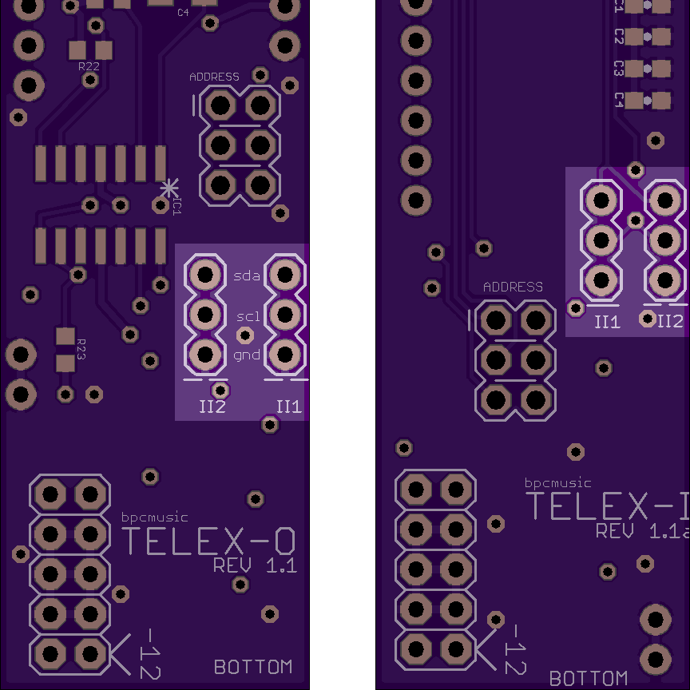

Fig. 1: TELEX II Connectors

The white lines below the columns on the PCB designate the locations of the ground wire.

Connecting Four or More II Devices

When connecting a larger number of devices to your Teletype, you will need to supply additional “pull-up” to the bus to have reliable communications. These handy bus boards (designed by Brian at monome) do the trick and are easy to build.

The iiBackpack mounts on the back side of your Teletype and provides twelve 2x3 II connection points. It is awesome.



Fig. 2: iiBackpack - https://oshpark.com/shared_projects/eVzh387f

The iiBusboard sits externally and provides eight 2x3 II connection points (one is taken up by the connection to your Teletype). Take care to ensure that the bottom of your iiBusboard isn’t shorting to anything metal in your case.



Fig. 3: iiBusboard - https://oshpark.com/shared_projects/FrAGyqU3

Connecting Multiple TELEX

A single II bus can support up to eight of each TELEX module type. You set a jumper on the back of the TELEX to differentiate the modules on your system after adding your first one of each type.

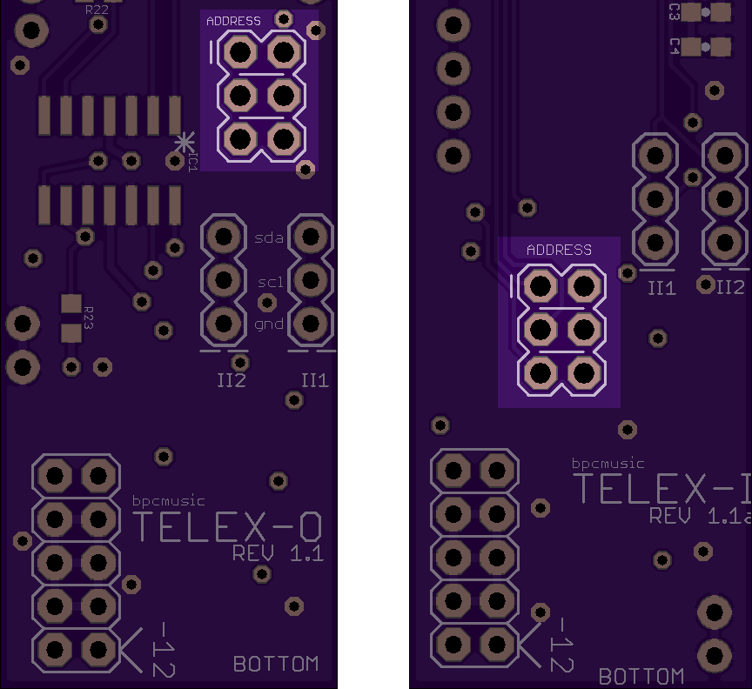

Fig. 4: Jumper Locations on TELEX

The number is coded in binary on the set of three jumpers on the back of your TELEX. The X in the chart below indicates where to install the included jumper if you want to rest your brain.

|  |  |  |  |  |
| --- | --- | --- | --- | --- |
| **Row 1** | **Row 2** | **Row 3** | **Unit #** | **Inputs/Outputs** |
| - | - | - | 1 | 1-4 |
| X | - | - | 2 | 5-8 |
| - | X | - | 3 | 9-12 |
| X | X | - | 4 | 13-16 |
| - | - | X | 5 | 17-20 |
| X | - | X | 6 | 21-24 |
| - | X | X | 7 | 25-28 |
| X | X | X | 8 | 28-32 |

The jumper is located within the little plastic bag of screws and stuff that you’ve lost since opening your module’s box. Check in the sofa cushions or in that place where your cat drags things. If you can’t find it, it is time to get creative.

Teletype & TELEX Basics

Addressing Units

Outputs and inputs added to the system by the TELEX modules are addressed sequentially: 1-4 are on your first module of any type, 5-8 are on the second, 9-12 on the third, and so on. A few of the commands reference the module by its unit number – but those are rare.

Command Groupings

* **Basic Commands** represent commands that have 1 to 1 equivalents in the Teletype command set
* **Extended Commands** represent commands that are new to the expanders but have close equivalents in the Teletype command set
* **Experimental Commands** are commands that are new functionality provided by the expanders; they push the expanders to the edge of performance and should be considered "dangerously fun"

Command Notes

* **n** represents the number of outputs or inputs that you have added to your Teletype (4 of each type for each expander)
* **x** represents the expander unit number as opposed to an output (1 for each expander)
* **α +** **β** represent the values that you are supplying to an operator that takes a parameter
* **α +** **β** values for control voltages are *bipolar* on the TELEXo - they accept values between -16384 to 16383

TELEXo (TXo) Commands

TXo Trigger Output (TR) Basic Commands

| **Command** | **Description** |
| --- | --- |
| TO.TR 1-n α | Set TR value to α (0/1) |
| TO.TR.TOG 1-n | Toggle TR |
| TO.TR.PULSE 1-n | Pulse TR using TO.TR.TIME/S/M as an interval |
| TO.TR.TIME 1-n α | time for TR.PULSE; α in ms |
| TO.TR.POL 1-n α | polarity for TO.TR.PULSE set to α (0-1) |

TXo Trigger Output (TR) Extended Commands

| **Command** | **Description** |
| --- | --- |
| TO.TR.TIME.S 1-n α | time for TR.PULSE; α in sec |
| TO.TR.TIME.M 1-n α | time for TR.PULSE; α in min |

TXo Trigger Output (TR) Experimental Commands:  
Divider + Metronomes

| **Command** | **Description** |
| --- | --- |
| TO.TR.PULSE.DIV 1-n α | pulse divider for TR output; α in # of pulses |
| TO.TR.M 1-n α | time for TR.M; α in ms |
| TO.TR.M.S 1-n α | time for TR.M; α in sec |
| TO.TR.M.M 1-n α | time for TR.M; α in min |
| TO.TR.M.BPM 1-n α | time for TR.M; α in Beats Per Minute |
| TO.TR.M.ACT 1-n α | activates the metronome for the TR output; α (0=off; 1=on) |
| TO.TR.M.COUNT 1-n α | sets the number of repeats before deactivating (0=infinity) |
| TO.TR.M.SYNC 1-n | synchronizes the metronome on the device # |
| TO.TR.WIDTH 1-n α | time for TR.PULSE; α percentage of TR.M |

TXo Control Voltage (CV) Basic Commands

| **Command** | **Description** |
| --- | --- |
| TO.CV 1-n α | CV target α (bipolar) |
| TO.CV.SLEW 1-n α | CV slew time; α in ms |
| TO.CV.SET 1-n α | set CV to α (bipolar); ignoring SLEW |
| TO.CV.OFF 1-n α | CV offset; α added at final stage |

TXo Control Voltage (CV) Extended Commands

| **Command** | **Description** |
| --- | --- |
| TO.CV.SLEW.S 1-n α | CV slew time; α in sec |
| TO.CV.SLEW.M 1-n α | CV slew time; α in min |
| TO.CV.QT 1-n α | CV target α; quantized to output's current CV.SCALE |
| TO.CV.QT.SET 1-n α | set CV to α; quantized to output's current CV.SCALE; ignoring SLEW |
| TO.CV.N 1-n α | CV target note # α in output's current CV.SCALE |
| TO.CV.N.SET 1-n α | set CV to note # α in output's current CV.SCALE; ignoring SLEW |
| TO.CV.SCALE 1-n α | select scale # α for individual CV output; see quantization scale reference below |

TXo Control Voltage (CV) Experimental Commands:  
Oscillator Functions

To start oscillation, set the frequency for the CV output to a value greater than zero. To return it to basic functionality, set it back to zero (0). When in oscillation mode, the current CV value sets the peak for the waveform - think of it like a volume or range control.

| **Command** | **Description** |
| --- | --- |
| TO.OSC 1-n α | targets oscillation to α (1v/oct translated) |
| TO.OSC.SET 1-n α | sets oscillation to α; ignores OSC.SLEW |
| TO.OSC.QT 1-n α | targets oscillation to α (1v/oct translated); quantized to current OSC.SCALE |
| TO.OSC.QT.SET 1-n α | sets oscillation to α in current OSC.SCALE; ignores OSC.SLEW |
| TO.OSC.N 1-n α | targets oscillation to note # α; quantized to current OSC.SCALE |
| TO.OSC.N.SET 1-n α | sets oscillation to note # α in current OSC.SCALE; ignores OSC.SLEW |
| TO.OSC.FQ 1-n α | targets oscillation to frequency α in Hz |
| TO.OSC.FQ.SET 1-n α | sets oscillation to frequency α in Hz; ignores OSC.SLEW |
| TO.OSC.LFO 1-n α | targets oscillation to frequency α in mHz (millihertz: 10^-3 Hz) |
| TO.OSC.LFO.SET 1-n α | sets oscillation to frequency α in mHz (millihertz: 10^-3 Hz); ignores OSC.SLEW |
| TO.OSC.WAVE 1-n α | set the waveform to sine (0), triangle (1000), saw (2000), pulse (3000), or noise (4000). Range is from 0 to 4999. Oscillator shape is blended in between the "pure" values. |
| TO.OSC.SYNC 1-n | resets the phase of the oscillator to zero |
| TO.OSC.PHASE 1-n α | sets the phase offset of the oscillator to α (0 to 16384) - range of one cycle; |
| TO.OSC.WIDTH 1-n α | sets the width of the pulse wave (3) to α (0 to 100) |
| TO.OSC.RECT 1-n α | rectifies the polarity of the oscillator to α (-2 to 2); see rectification reference |
| TO.OSC.SLEW 1-n α | sets the slew time for the oscillator (portamento) to α (ms) |
| TO.OSC.SLEW.S 1-n α | sets the slew time for the oscillator (portamento) to α (sec) |
| TO.OSC.SLEW.M 1-n α | sets the slew time for the oscillator (portamento) to α (min) |
| TO.OSC.SCALE 1-n α | sets the quantization scale for the oscillator to scale # α (listed below) |
| TO.OSC.CYC 1-n α | targets the cycle length for the oscillator to α (ms) |
| TO.OSC.CYC.S 1-n α | targets the cycle length for the oscillator to α (sec) |
| TO.OSC.CYC.M 1-n α | targets the cycle length for the oscillator to α (min) |
| TO.OSC.CYC.SET 1-n α | sets the cycle length for the oscillator to α (ms) |
| TO.OSC.CYC.S.SET 1-n α | sets the cycle length for the oscillator to α (sec) |
| TO.OSC.CYC.M.SET 1-n α | sets the cycle length for the oscillator to α (min) |

TXo Control Voltage (CV) Experimental Commands:   
Envelope Generator

When you activate the envelope (using ENV.ACT) your CV output will drop to zero. You need to trigger the envelope (ENV.TRIG) in order to get it to play. This will interact with your currently set CV value for the output making that the (bipolar capable) peak for the envelope. Also, this will interact with the oscillator as well and become a virtual VCA for its output.

| **Command** | **Description** |
| --- | --- |
| TO.ENV.ACT 1-n α | activates the envelope generator for the CV output; α (0 = off; 1 = on) |
| TO.ENV.ATT 1-n α | Envelope attack time; α in ms |
| TO.ENV.ATT.S 1-n α | Envelope attack time; α in sec |
| TO.ENV.ATT.M 1-n α | Envelope attack time; α in min |
| TO.ENV.DEC 1-n α | decay time for the envelope; α in ms |
| TO.ENV.DEC.S 1-n α | decay time for the envelope; α in sec |
| TO.ENV.DEC.M 1-n α | decay time for the envelope; α in min |
| TO.ENV.TRIG 1-n | triggers the envelope to play |

TXo Global Commands

This affects both trigger (TR) and control voltage (CV) outputs.

| **Command** | **Description** |
| --- | --- |
| TO.KILL | cancels TR pulses and CV slews |

TXo Rectification Reference

There are several rectification modes available in the oscillator. They are listed below:

| **Mode** | **Behavior** |
| --- | --- |
| -2 | inverts positive values making them negative |
| -1 | omits all positive values |
| 0 | no rectification; wave is unaffected bipolar |
| 1 | omits all negative values |
| 2 | inverts negative values making them positive |

TELEXi (TXi) Commands

TXi Basic Commands

| **Command** | **Description** |
| --- | --- |
| TI.IN 1-n | reads the value of the CV input jack  (-16384 to 16383) |
| TI.PARAM 1-n | reads the value of the PARAM knob  (0 to 16383) |

TXi Extended Commands

| **Command** | **Description** |
| --- | --- |
| TI.IN.QT 1-n | return the quantized value for the IN jack; uses input's IN.SCALE |
| TI.IN.N 1-n | return the quantized note number for the IN jack; uses the input's IN.SCALE |
| TI.IN.SCALE 1-n α | sets the current scale for the input to α; see scale reference below |
| TI.IN.MAP 1-n α β | maps the IN values to α - β |
| TI.PARAM.QT 1-n | return the quantized value for the PARAM knob; uses knob's PARAM.SCALE |
| TI.PARAM.N 1-n | return the quantized note number for the PARAM knob; uses knob's PARAM.SCALE |
| TI.PARAM.SCALE 1-n α | sets the current scale for the param knob to α; see scale reference below |
| TI.PARAM.MAP 1-n α β | maps PARAM values across α - β |

TXi Experimental Commands

The calibration settings allow you to scale your input values for the IN jacks and the PARAM knobs to compensate for component tolerances. The calibration procedures are listed in the Calibration Details section.

Only the TXi currently has calibration capabilities; these features have not been implemented for the TXo for performance reasons.

Your TXi **WAS NOT** calibrated at the factory. This is consistent with the behavior of the Teletype’s IN and PARAM knobs. If you are OCD (like we are) and wish to match the range of your inputs to the numerical outputs more closely, the software calibration procedure outlined below is for you.

| **Command** | **Description** |
| --- | --- |
| TI.IN.CALIB 1-n α | calibrates the scaling for the IN jack; see calibration details below |
| TI.PARAM.CALIB 1-n α | calibrates the scaling for the PARAM knob; see calibration details below |
| TI.STORE 1-x | stores the calibration data for the expander to its flash memory |
| TI.RESET 1-x | resets the calibration data to factory defaults |

TXi Calibration Procedure

Calibration for the input module works as follows:

*IN Calibration:*

1. Send a -10V signal to the input Z
2. Send the command 'TI.IN.CALIBRATE Z -1'
3. Send a 0V signal to the input Z
4. Send the command 'TI.IN.CALIBRATE Z 0'
5. Send a 10V signal to the input Z
6. Send the command 'TI.IN.CALIBRATE Z 1'

PARAM Calibration:

1. Turn the PARAM knob Z all the way to the left
2. Send the command 'TI.PARAM.CALIBRATE Z 0'
3. Turn the PARAM knob Z all the way to the right
4. Send the command 'TI.PARAM.CALIBRATE Z 1'

Save and Reset

* You can save the calibration data for a device by sending 'TI.STORE N'. N is the number of the device - not the number of an input.
* You can reset the calibration data for a device by sending 'TI.RESET N'. N is the number of the device - not the number of an input.

Quantization Scale Reference

| **Scale** | **Name** |
| --- | --- |
| 0 | Standard 12 Tone Equal Temperament **[DEFAULT]** |
| 1 | 12-tone Pythagorean scale |
| 2 | Vallotti & Young scale (Vallotti version) also known as Tartini-Vallotti (1754) |
| 3 | Andreas Werckmeister's temperament III (the most famous one, 1681) |
| 4 | Wendy Carlos' Alpha scale with perfect fifth divided in nine |
| 5 | Wendy Carlos' Beta scale with perfect fifth divided by eleven |
| 6 | Wendy Carlos' Gamma scale with third divided by eleven or fifth by twenty |
| 7 | Carlos Harmonic & Ben Johnston's scale of 'Blues' from Suite f.micr.piano (1977) & David Beardsley's scale of 'Science Friction' |
| 8 | Carlos Super Just |
| 9 | Kurzweil "Empirical Arabic" |
| 10 | Kurzweil "Just with natural b7th", is Sauveur Just with 7/4 |
| 11 | Kurzweil "Empirical Bali/Java Harmonic Pelog" |
| 12 | Kurzweil "Empirical Bali/Java Slendro, Siam 7" |
| 13 | Kurzweil "Empirical Tibetian Ceremonial" |
| 14 | Harry Partch's 43-tone pure scale |
| 15 | Partch's Indian Chromatic, Exposition of Monophony, 1933. |
| 16 | Partch Greek scales from "Two Studies on Ancient Greek Scales" on black/white |